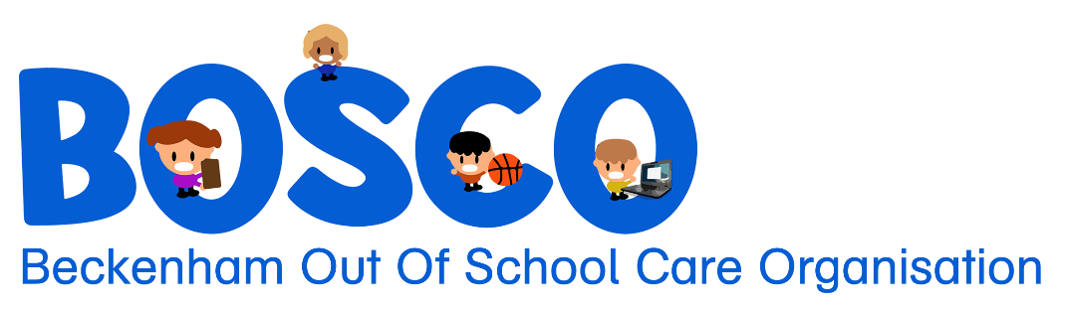
71 Sandwich Rd, Beckenham
Christchurch, 8023
027 645 6632
office@bosco.org.nz
www.bosco.org.nz
Charitable Status: CC40574

Behaviour Management Policy

Children are expected to follow the code of behaviour:

* To behave in such a manner that does not impinge on the rights and enjoyment of others, or damage equipment or property.
* To abide by requests/instructions from programme Staff.
* To abide by the rules of BOSCO Incorporated (including school rules).
* To remain in the environment of the programme unless authorized by their parent/caregiver or Staff to leave.
* To come straight to BOSCO Incorporated after the school bell rings.

At all times Staff will maintain a fair, consistent and positive approach to children’s behaviour. At no
time will children be physically punished, disciplined, or treated in a way that is degrading,
humiliating or cause fear or anxiety. Children will only be physically restrained if their immediate
safety or the safety of others is at risk and verbal commands have failed. A second Staff member must
be present.

These will be located on the wall for children, parents/caregivers, and Staff to see at all times.

To encourage appropriate behaviour Staff will incorporate a reward scheme that works best for
majority of the children and suit a variety of ages. This will vary depending on what works best for
the children and staff. The focus of the scheme will be on reinforcing positive behaviour.

When children are in conflict with each other, Staff will act as mediators where possible to help the
children to resolve the situation themselves and aid them by making suggestions on how to do so to
ensure the situation is resolved in a safe and healthy environment. If children cannot resolve the
conflict, they will be removed from the situation, for example they will not be allowed to play with
the toy or with each other.

If a child displays unacceptable behaviour, permitted discipline measures include:
* Verbal reprimand with preferred behaviour stated.
* Removal of privileges, e.g., not allowed on chrome books
* Reparation, e.g., picking up what has been thrown and apologizing.
* Quiet time – the child is encouraged to sit in the quiet zone in the office for an appropriate time (i.e. one (1) minute per age) to consider their behaviour. The child will have a chat to a staff member about what they could have done differently and why the certain behaviour is unacceptable before returning to the group to play.
* Where behaviour endangers self or others, the parent/caregiver is to be contacted immediately to collect the child.

All disciplinary procedures are to be recorded on an Incident Form by Staff (in consultation with the
Programme Leader), signed and placed in the child’s incident and accident file.

The Programme Leader or Supervisor will discuss the behaviour with the parent/caregiver when they
come to collect the child and have the parent/caregiver sign the Incident Form.

If disciplinary procedures fail to manage the unacceptable behaviour (for example, the behaviour
occurs repeatedly or frequently) then the Programme Leader will notify the committee and
contact the parents/caregivers the same day to arrange a meeting with a member of the committee to
discuss the child’s on-going enrolment at BOSCO.

A meeting with the parent/caregiver, Programme Leader, Supervisor, and the Chairperson regarding a child’s on-going enrolment may result in the following outcomes:
- A behaviour management plan may be implemented by the Programme Leader in consultation with the parent/caregiver and with approval from the Management Committee. The plan must include desired outcomes and a timeframe.
- A recommendation is made to the committee to suspend the child for a fixed period of time after which time the child will be allowed to return to the program. The decision to suspend a child is taken only after all other options have been explored with both the parent/caregiver and the child. The parent/caregiver must receive written notification of the suspension from the Programme leader
- A recommendation is made to the Management Committee to terminate the enrolment of the child. The decision to terminate enrolment is taken only after all other options have failed or the safety of the other children or Staff at the program is threatened. The parent/caregiver must receive written notification of termination of enrolment from the Programme Leader or Management Committee.

